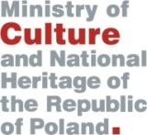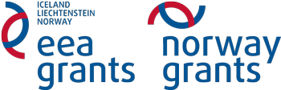

The Partnership Seminar
“Conservation and Revitalization of Cultural Heritage”
Warsaw, 19-20 August 2013
AGENDA:
Monday, 19 August
19:30 - 22:00 Reception
Tuesday, 20 August
10:00 Registration
10:30 - 12:30 Presentations, including:
      - Introduction to the Programme
      - The Donor States perspective
      - Partnership experience in the cultural heritage projects
      - The idea of partnership within the Programme
12:30 - 13:30 Lunch
13:30 - 15:30 Workshop: matchmaking session in groups
16:00 - 17:30 Guided tour of the Warsaw Old Town

